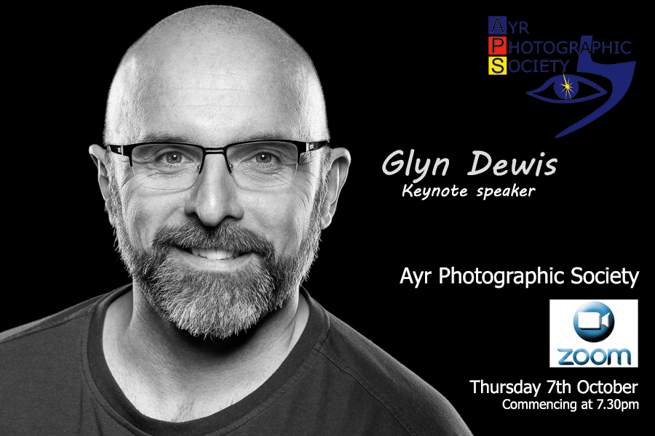

Glyn Dewis is a Photographer, Educator, Speaker and Best Selling Author based in Devon, UK.

A Photoshop World Dream Team Instructor, KelbyOne Instructor, Sony Alpha Creator, Westcott Top Pro and in 2017 Glyn was awarded Adobe Max Master following his presentations in Las Vegas of that year.

Glyn regularly presents at events around the world covering all aspects of Photography and Post Production.

Founder of the 39-45 World War 2 Veterans Portraits Project.
Glyn is also Ambassador of The Veterans Charity: an immediate needs charity for veterans who face hardship and distress.

Join us for this presentation as photographer and author Glyn Dewis takes us through how, when unable to take portraits during lockdowns, he began to experiment with other genres of photography from landscape and seascape to macro, in a concerted effort to keep busy, keep creative and to keep the tools in his hands.

However, what was to be a temporary fix has become so much more, now providing unlimited content, unlimited photographic possibilities and a new skillset. “I’ve always loved photography but venturing into different areas that ordinarily I wouldn’t has had a hugely positive impact. It almost feels like I’ve discovered photography all over again.”

